22.08.14
The status of the testing of electronics for COMET ECAL system:
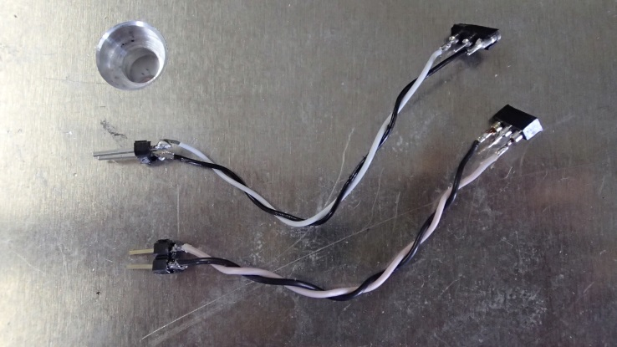
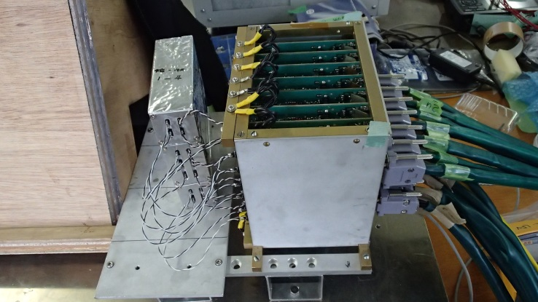
- To measure the noise level the stand was made, consisting of blocks set of crystals (3 units – 2 by 4 crystals and 1 by 6 crystals), the amplifier boards, VME convert boards, VME digitizer. Noise level measurements were made with new twisted pairs cables (small cables ~ 5cm and big ~ 17cm) between APD and amplifiers for comparison with previous measurements (beam-test in Feb.2014).
Fig.1
On the Figure 1 are shown the new cables (small on the left picture and big on the right)
Fig.2
Fig. 2 shown the three stages of noise level measurement. The graphs with distribution of the noise level in the amplifier channels are shows below. In all measurements were used one and same photodiodes and amplifier board (№8). In the tests with cables were used HV and cooler with temp. ~20º.
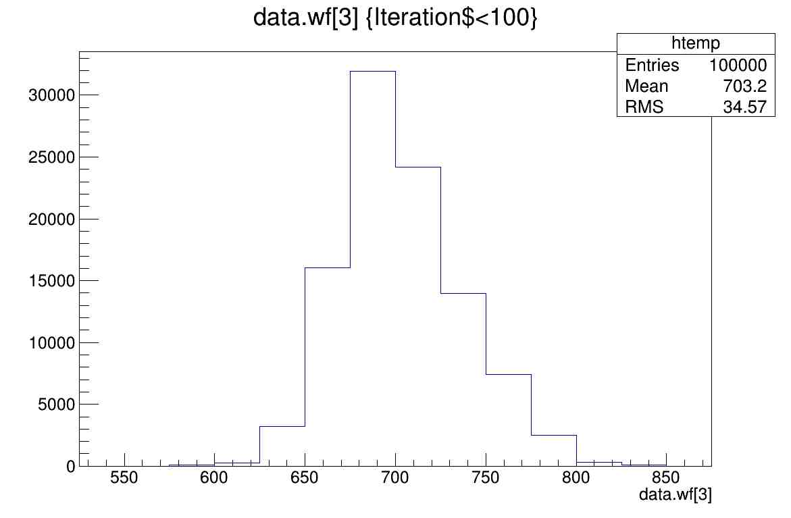
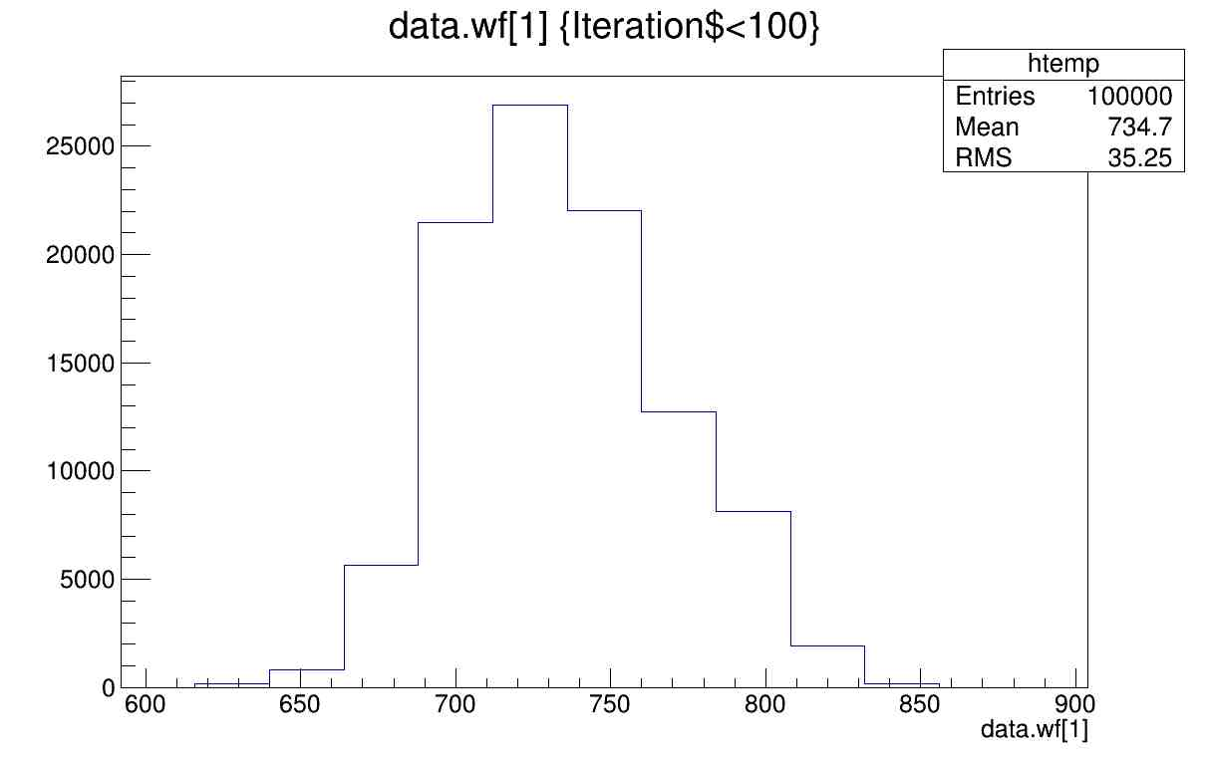
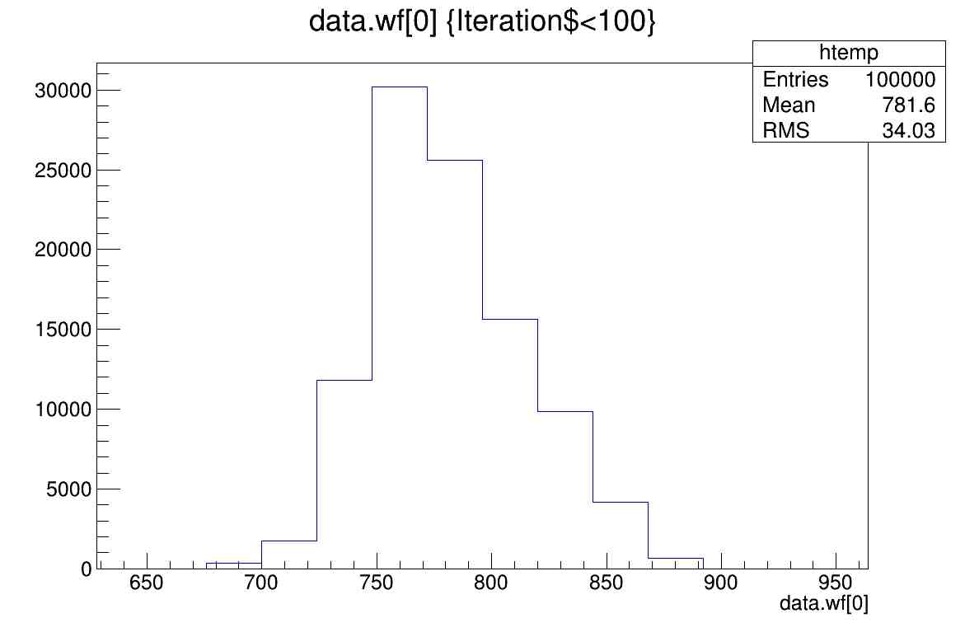
- The ideal case when the amplifiers are not connected to the photodiodes.
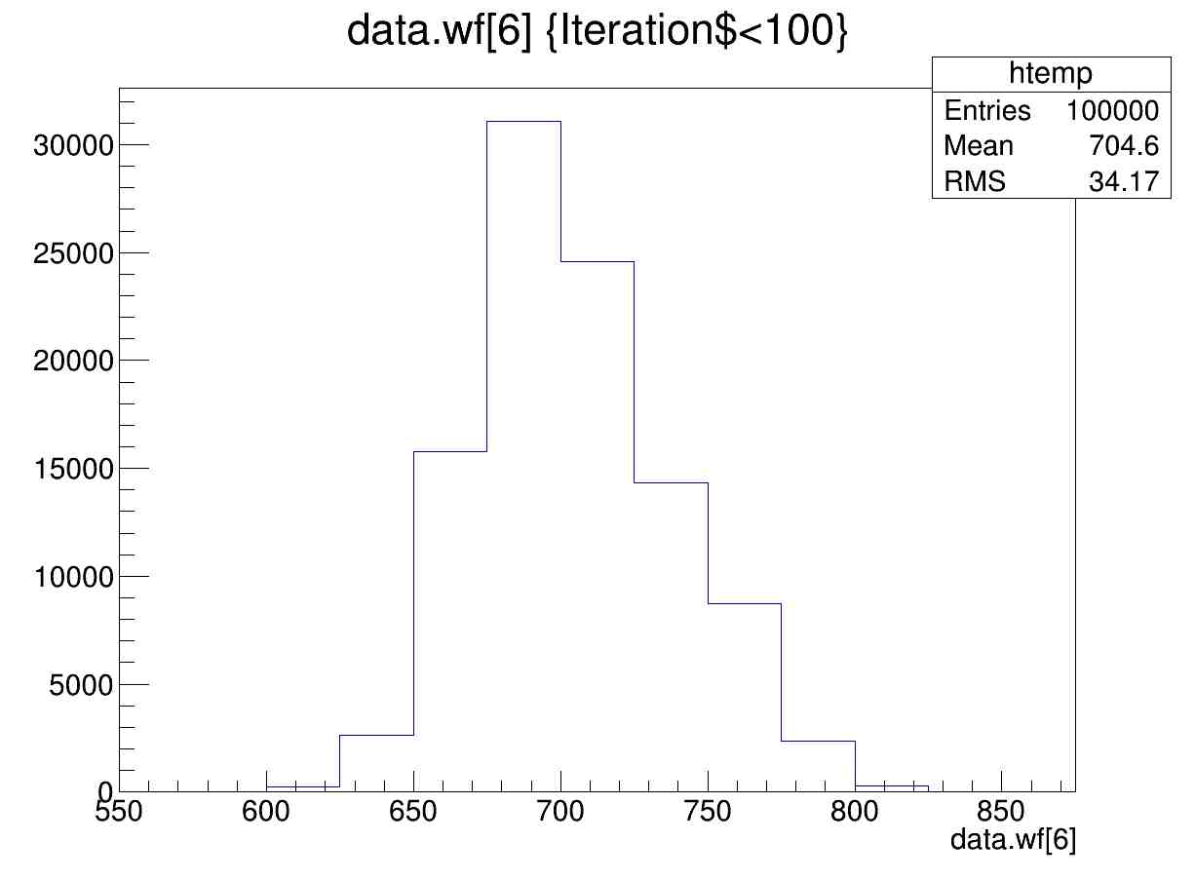
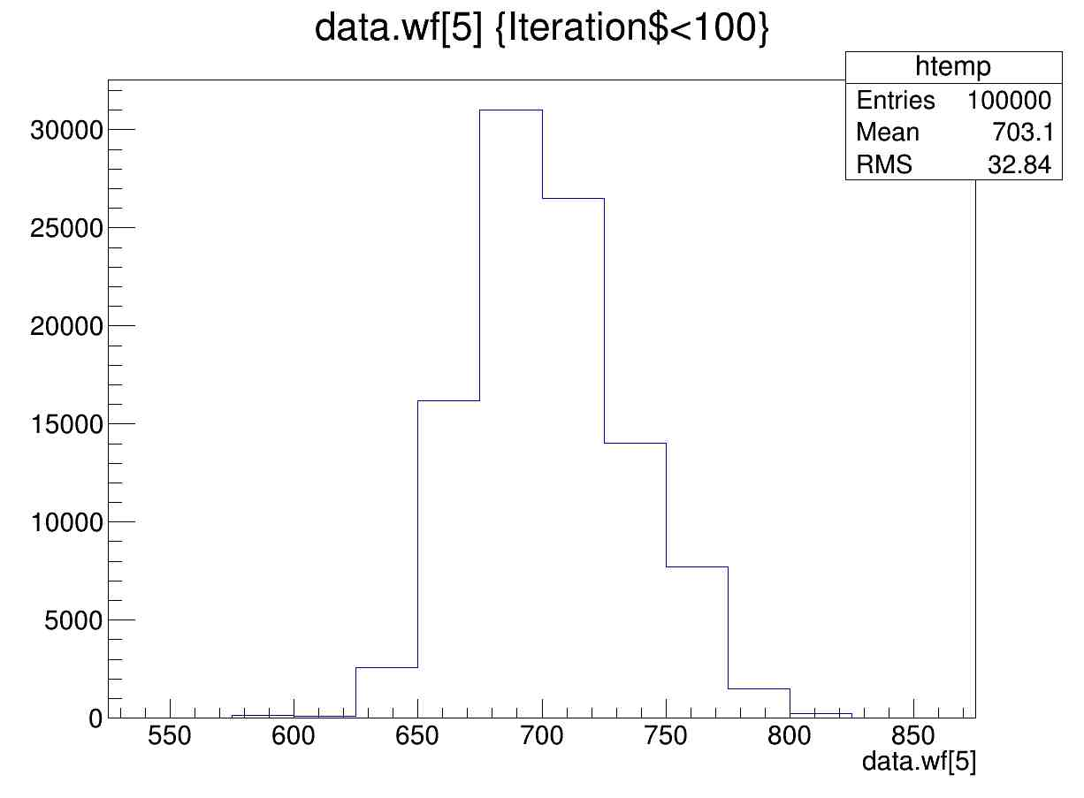
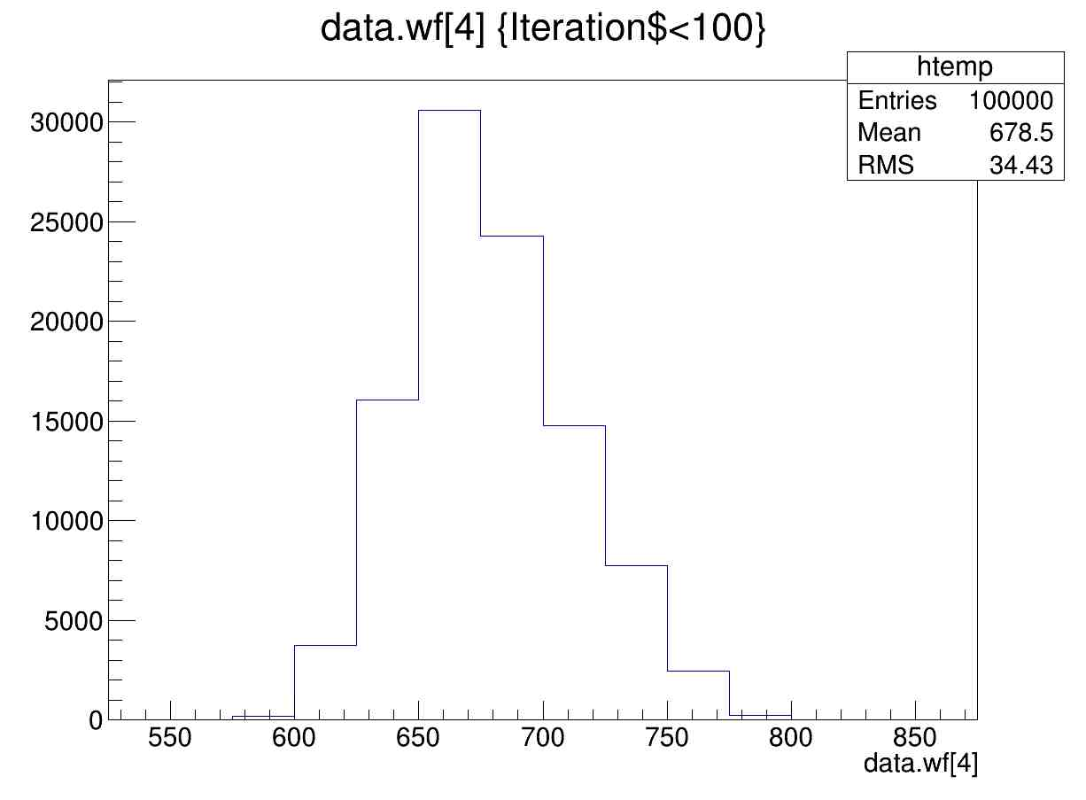
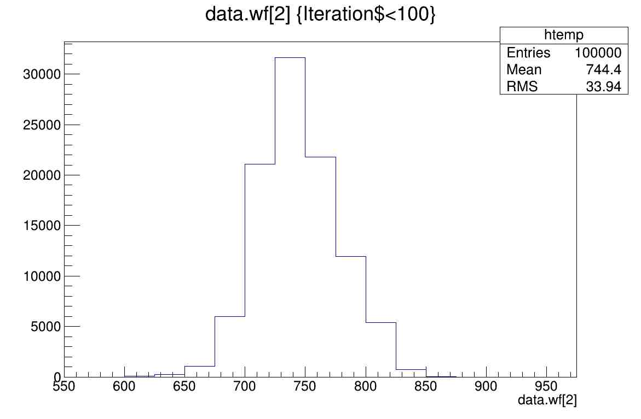

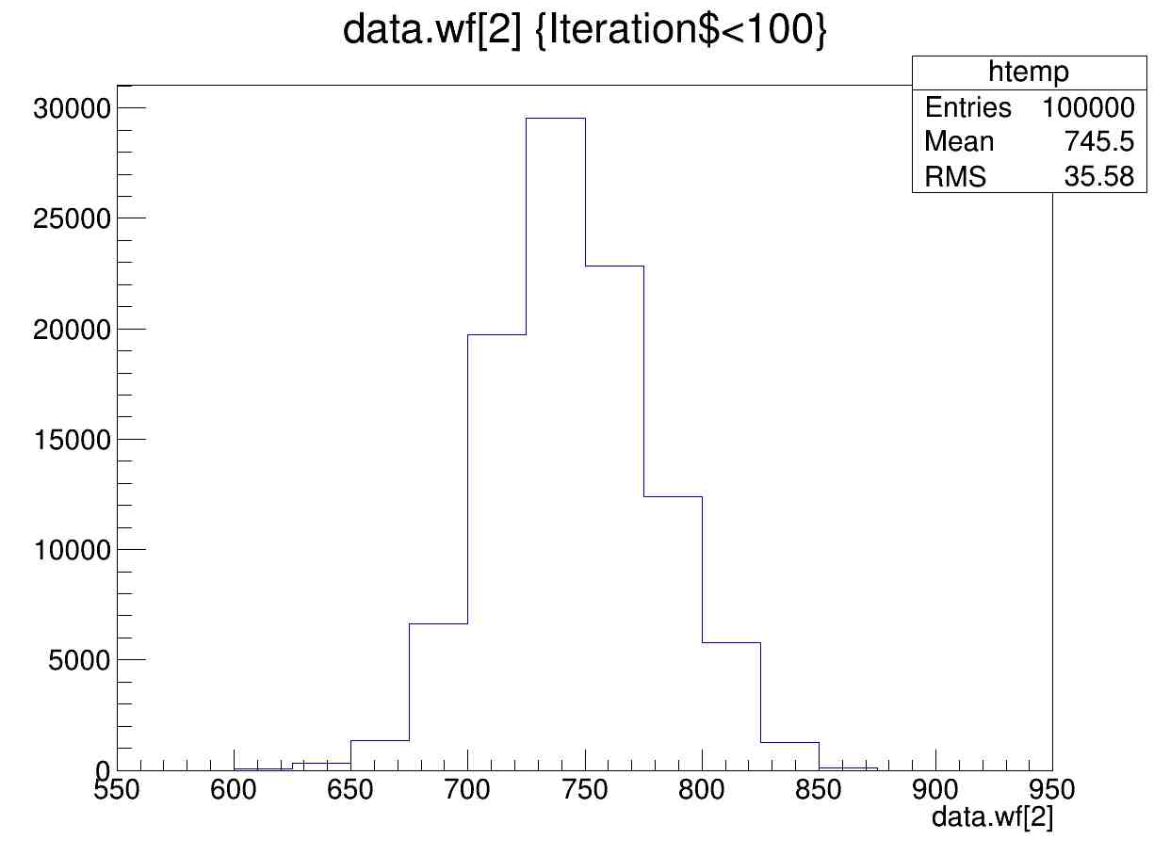
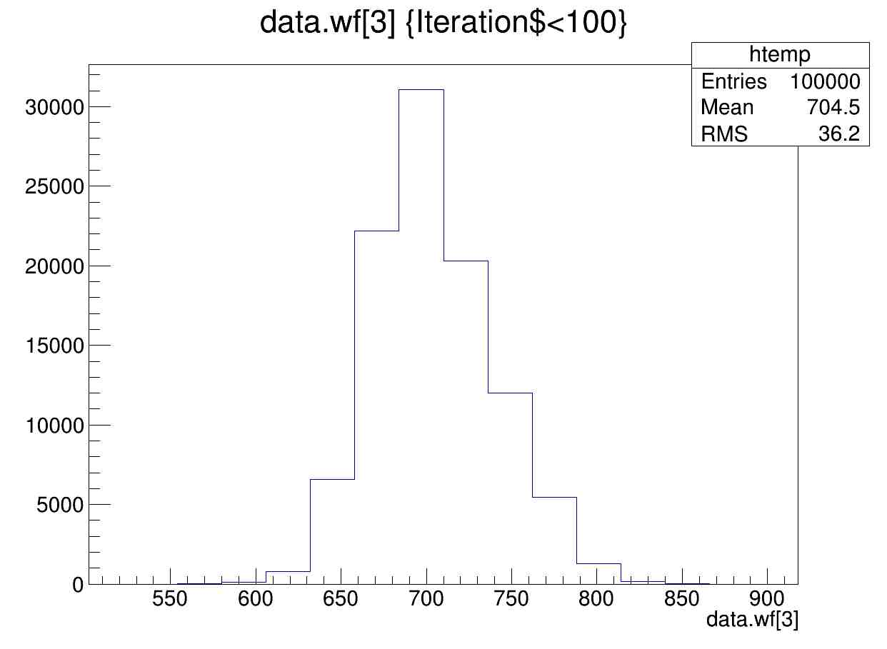
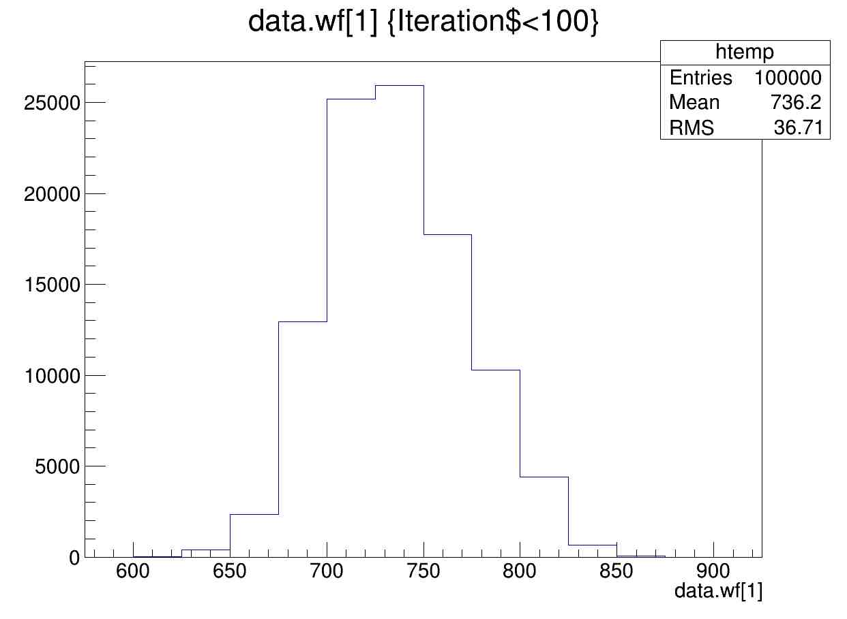
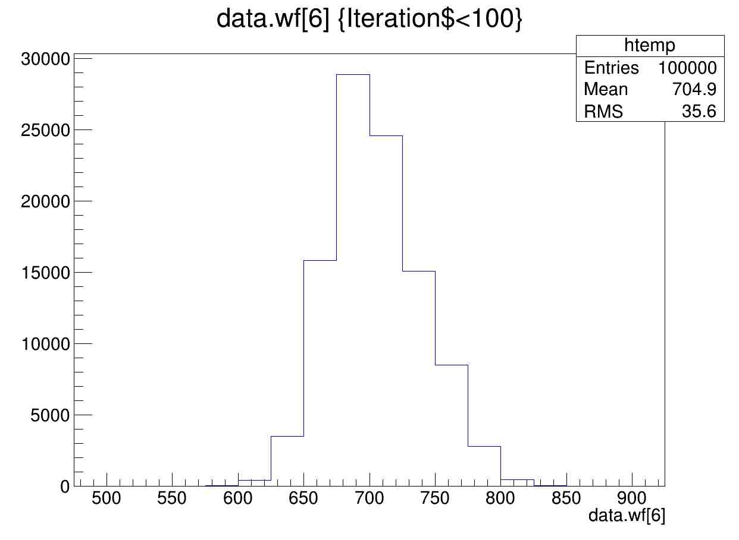
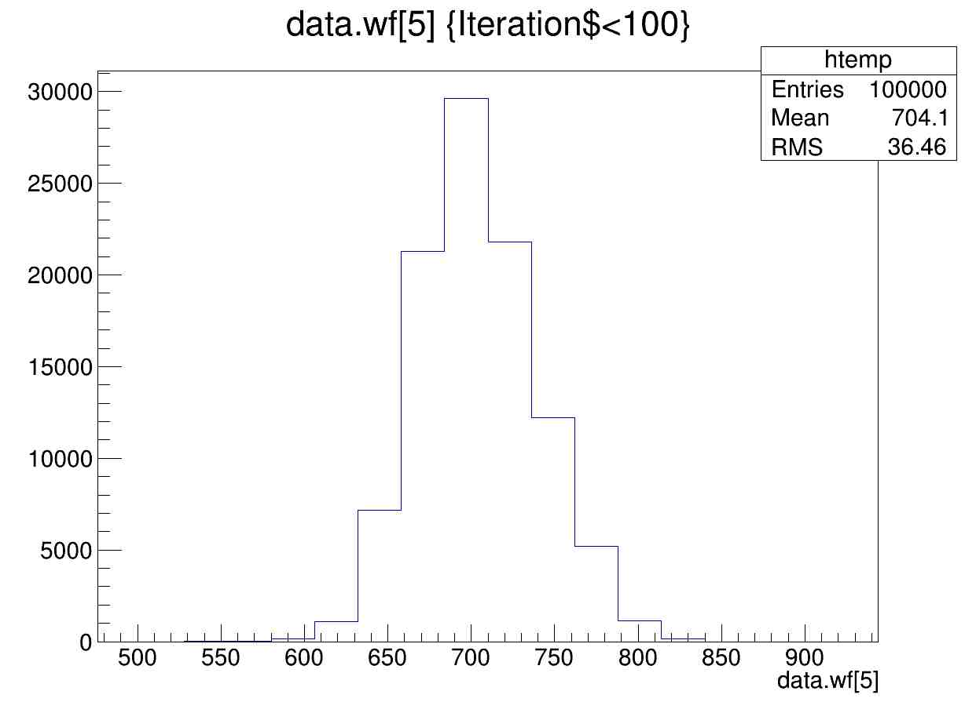
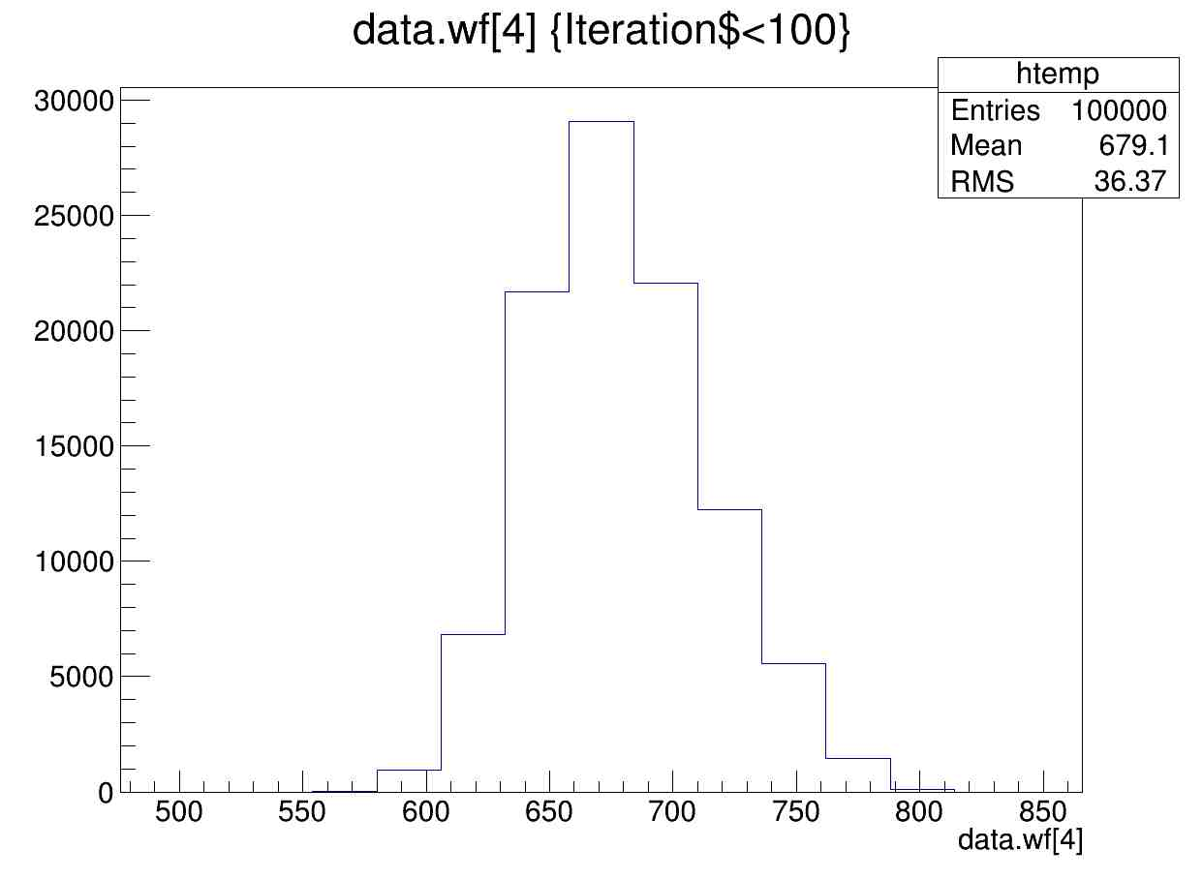
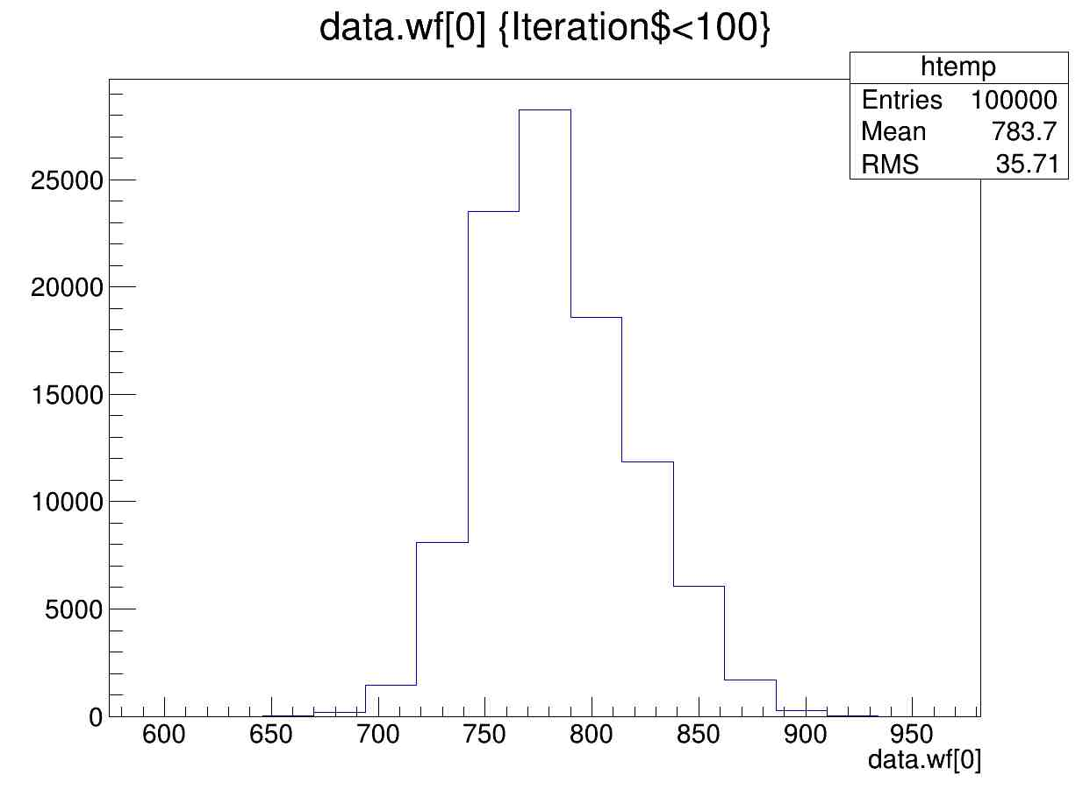
- The case, when the amplifiers were connected to the photodiodes thought small cables.
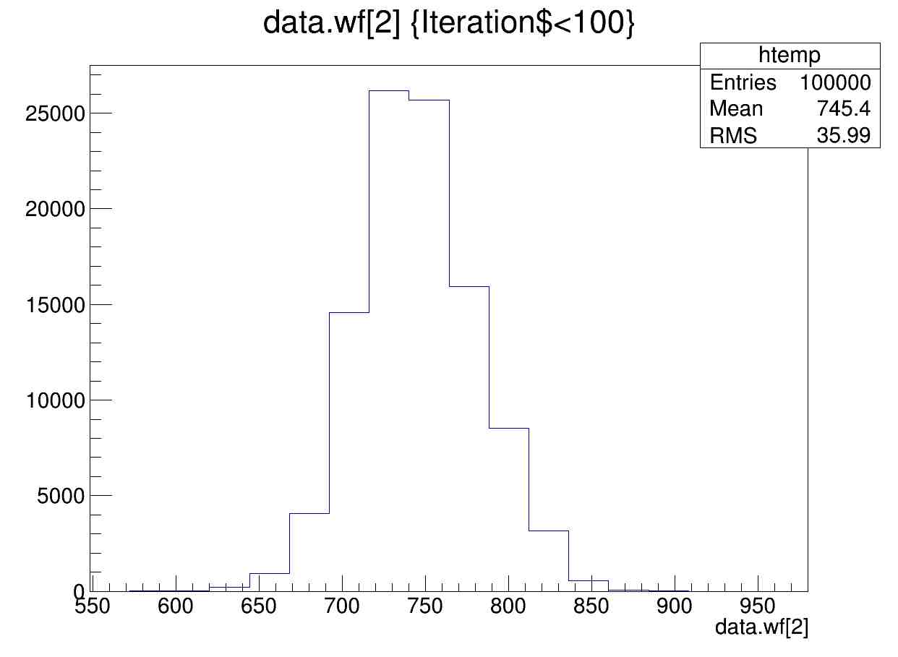
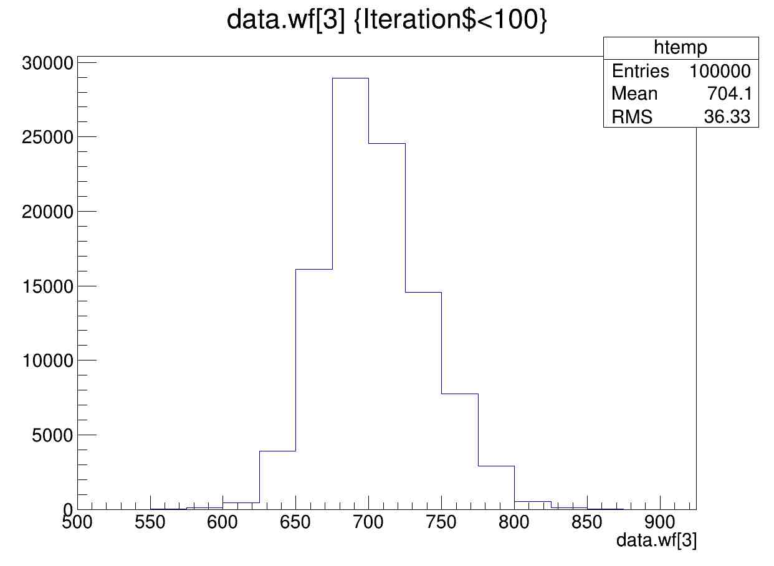
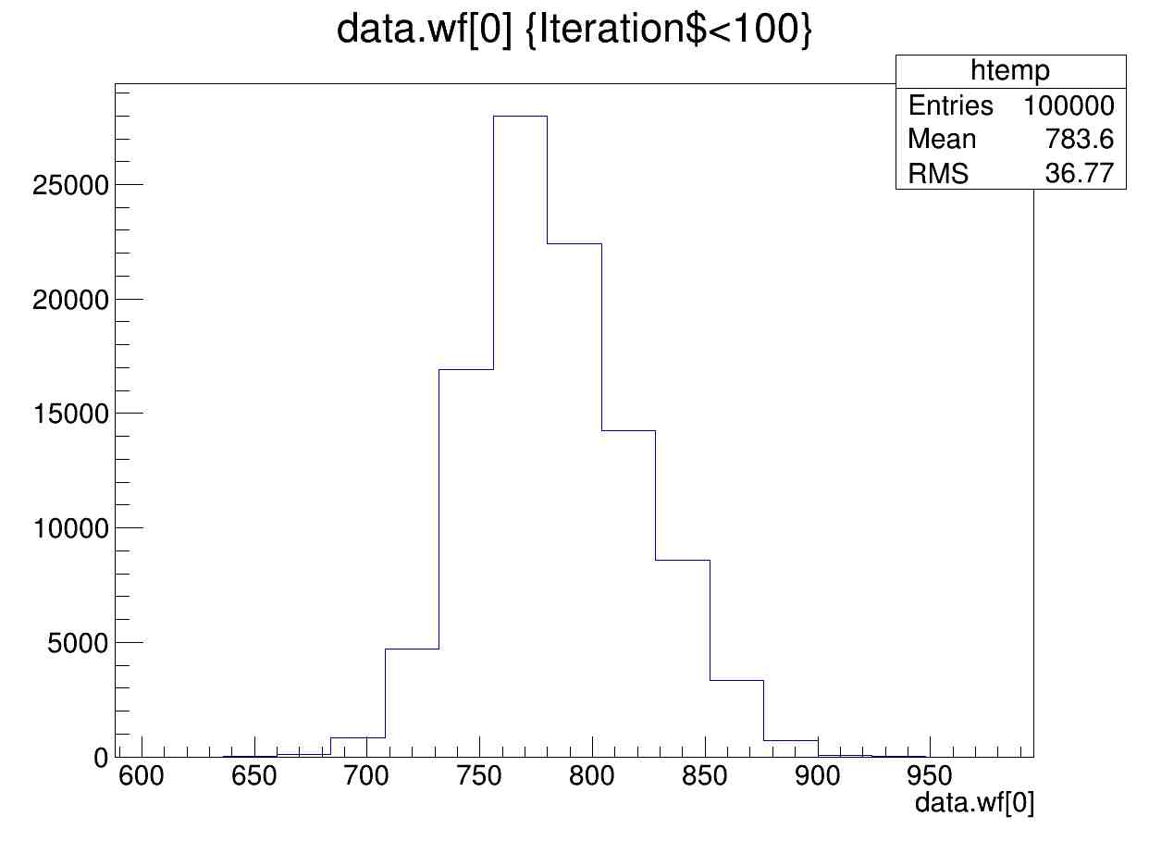
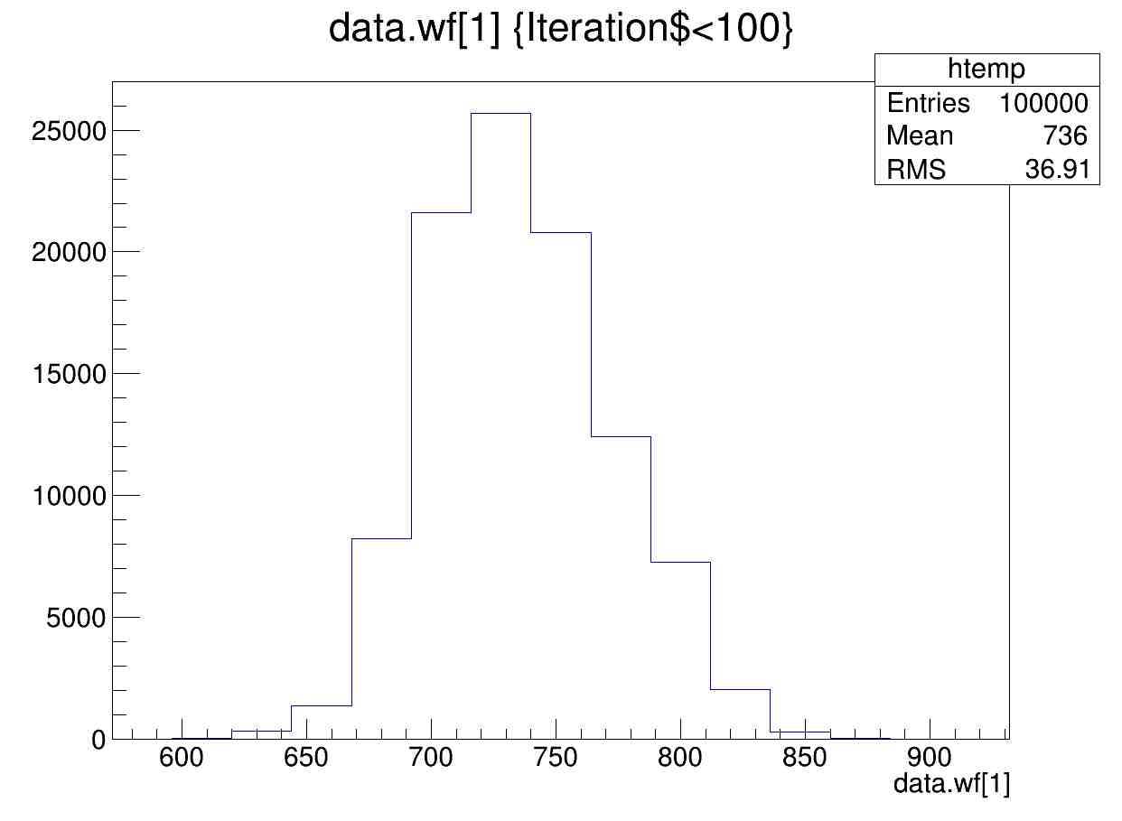
- The case, when the amplifiers were connected to the photodiodes thought big cables.
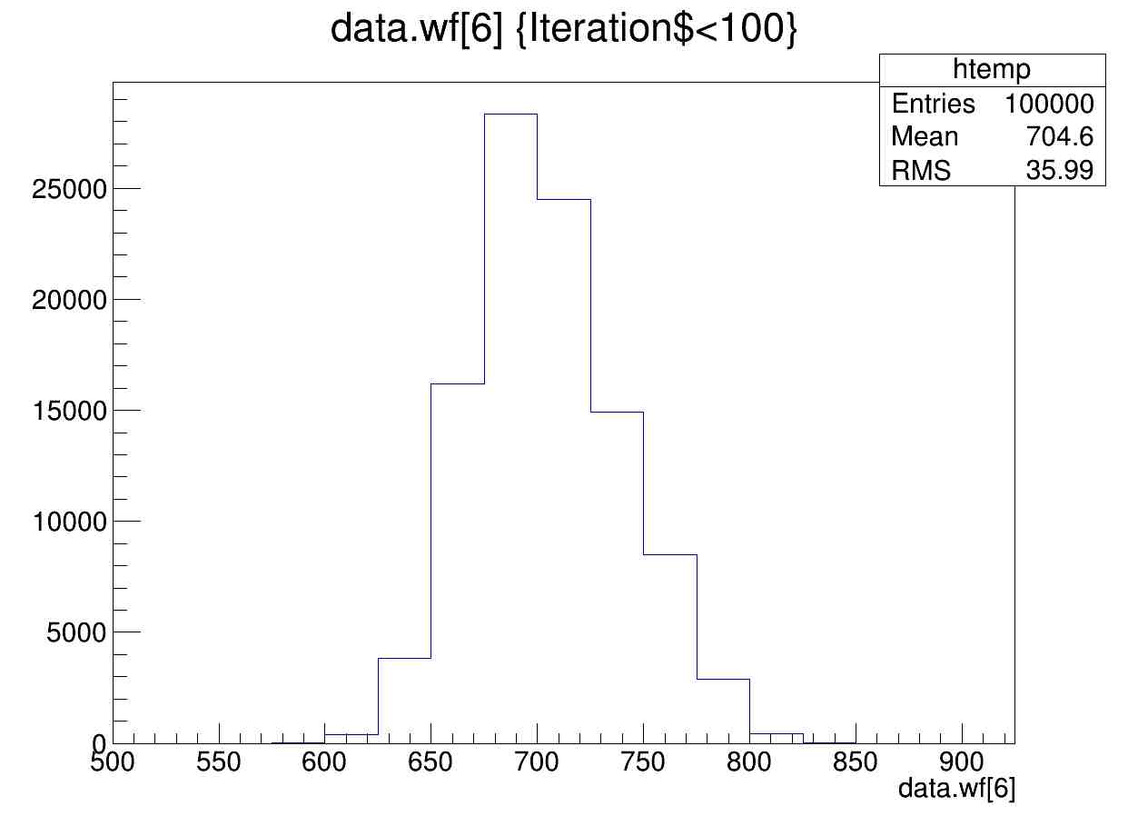
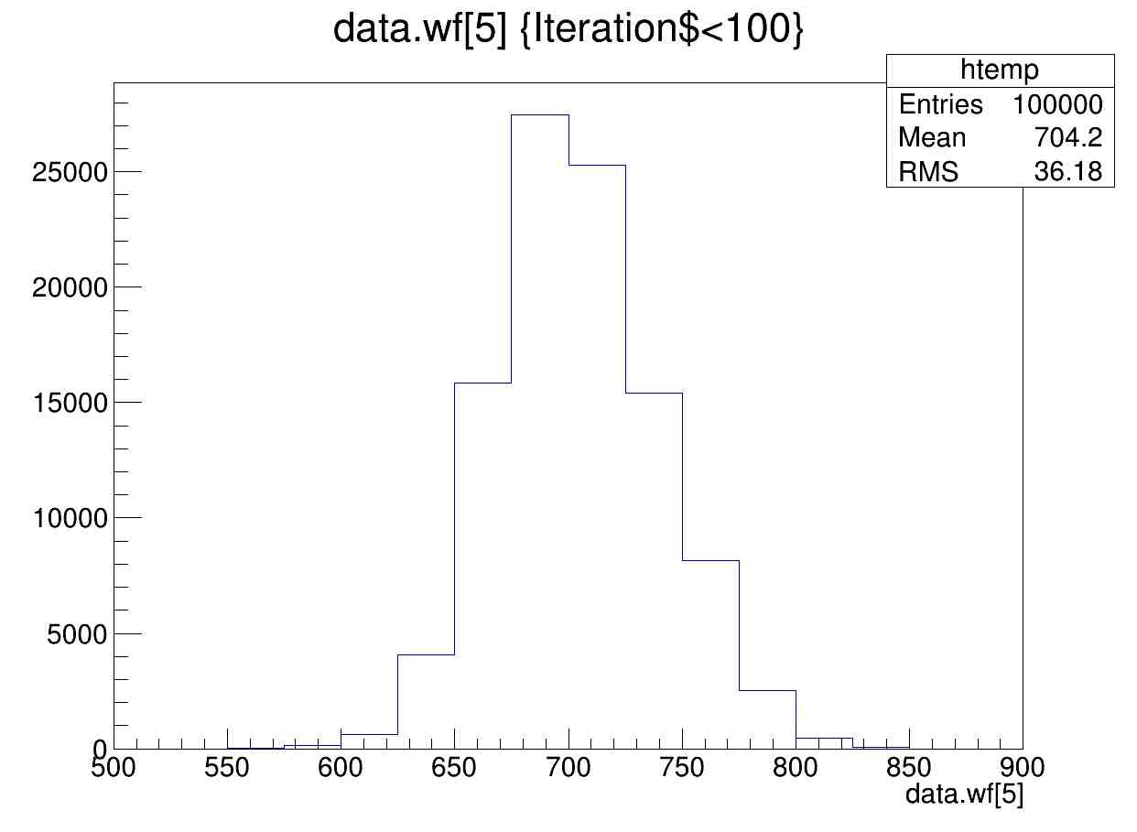
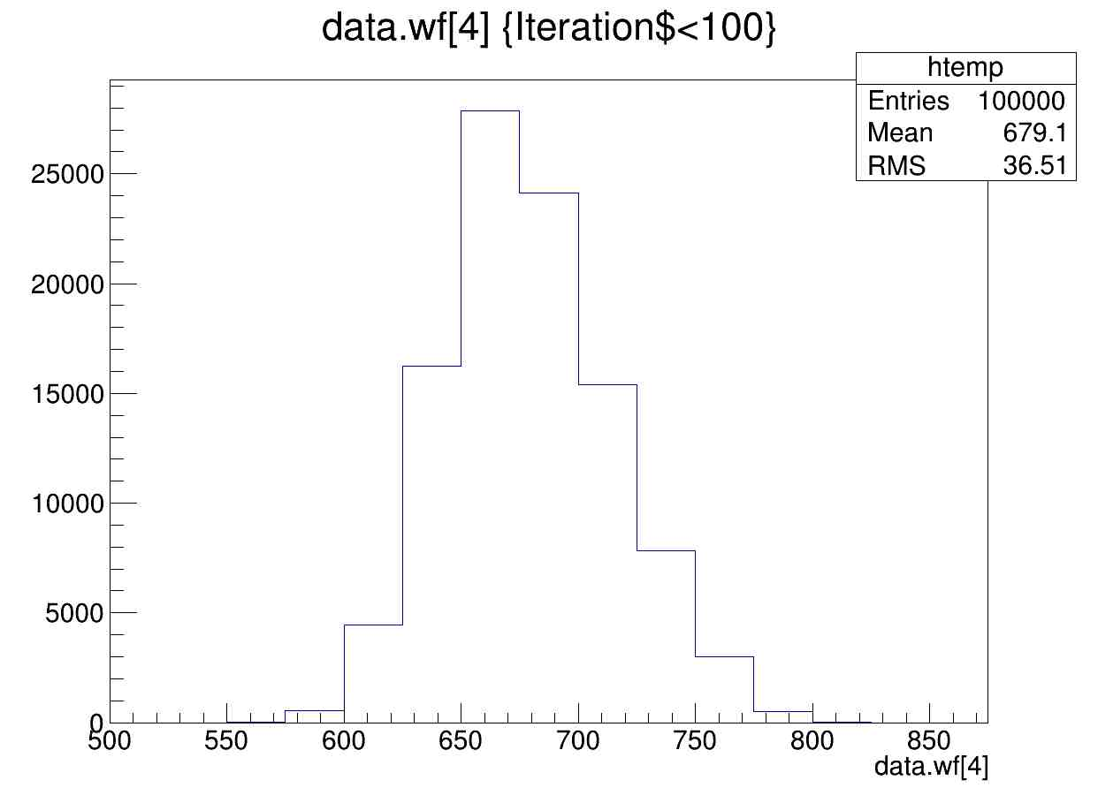

- The ROESTI testing for COMET ECAL:
The stand for testing was made, consisting of blocks set of crystals (3 units – 2 by 4 crystals and 1 by 6 crystals), the amplifier boards, new small board for converting the signals between amplifiers and ROESTI, ROESTI.
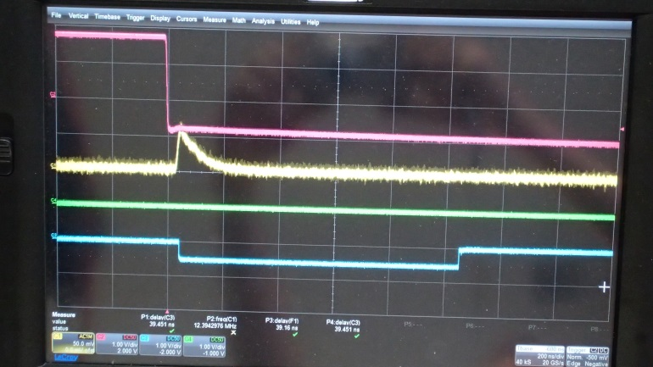
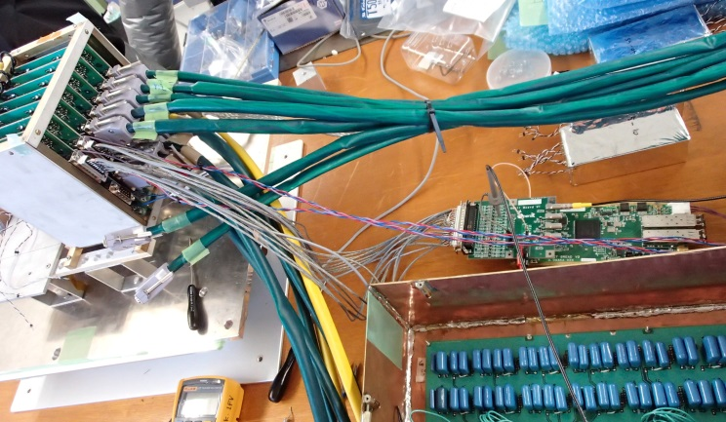
- The Efficiency of the small board has been verified with generator signal:
Also for ROESTI testing has been made a system with cosmic counter for creating a trigger signals.
The next step will be adding ROESTI board to the system and testing with it.

